TEST ON SEMICONDUCTORS

|  |  |  |
| --- | --- | --- |
|  | 1. | Intrinsic semiconductor material is characterized by a valence shell of how many electrons? |
|  | |  |  | | --- | --- | | [A.](javascript:%20void%200;) | 1 | | [B.](javascript:%20void%200;) | 2 | | [C.](javascript:%20void%200;) | 4 | | [D.](javascript:%20void%200;) | 6 | |

|  |  |
| --- | --- |
| 2. | What is an energy gap? |
| |  |  | | --- | --- | | [A.](javascript:%20void%200;) | the space between two orbital shells | | [B.](javascript:%20void%200;) | the energy equal to the energy acquired by an electron passing a 1 V electric field | | [C.](javascript:%20void%200;) | the energy band in which electrons can move freely | | [D.](javascript:%20void%200;) | an energy level at which an electron can exist | |

|  |  |
| --- | --- |
| 3. | Silicon atoms combine into an orderly pattern called a: |
| |  |  | | --- | --- | | [A.](javascript:%20void%200;) | covalent bond | | [B.](javascript:%20void%200;) | crystal | | [C.](javascript:%20void%200;) | semiconductor | | [D.](javascript:%20void%200;) | valence orbit | |

|  |  |
| --- | --- |
| 4. | In "n" type material, majority carriers would be: |
| |  |  | | --- | --- | | [A.](javascript:%20void%200;) | holes | | [B.](javascript:%20void%200;) | dopants | | [C.](javascript:%20void%200;) | slower | | [D.](javascript:%20void%200;) | electrons | |

|  |  |
| --- | --- |
| 5. | Elements with 1, 2, or 3 valence electrons usually make excellent: |
| |  |  | | --- | --- | | [A.](javascript:%20void%200;) | conductors | | [B.](javascript:%20void%200;) | semiconductors | | [C.](javascript:%20void%200;) | insulators | | [D.](javascript:%20void%200;) | neutral | |

|  |  |
| --- | --- |
| 6. | A commonly used pentavalent material is: |
| |  |  | | --- | --- | | [A.](javascript:%20void%200;) | arsenic | | [B.](javascript:%20void%200;) | boron | | [C.](javascript:%20void%200;) | gallium | | [D.](javascript:%20void%200;) | neon | |

|  |  |
| --- | --- |
| 7. | Which material may also be considered a semiconductor element? |
| |  |  | | --- | --- | | [A.](javascript:%20void%200;) | carbon | | [B.](javascript:%20void%200;) | ceramic | | [C.](javascript:%20void%200;) | mica | | [D.](javascript:%20void%200;) | argon | |
|  |  |
| 8. | In "p" type material, minority carriers would be: |
| |  |  | | --- | --- | | [A.](javascript:%20void%200;) | holes | | [B.](javascript:%20void%200;) | dopants | | [C.](javascript:%20void%200;) | slower | | [D.](javascript:%20void%200;) | electrons | |

|  |  |
| --- | --- |
| 9. | Electron pair bonding occurs when atoms: |
| |  |  | | --- | --- | | [A.](javascript:%20void%200;) | lack electrons | | [B.](javascript:%20void%200;) | share holes | | [C.](javascript:%20void%200;) | lack holes | | [D.](javascript:%20void%200;) | |  | | --- | | share electrons | | |

|  |  |
| --- | --- |
| 10. | When an electron jumps from the valence shell to the conduction band, it leaves a gap. What is this gap called? |
| |  |  | | --- | --- | | [A.](javascript:%20void%200;) | energy gap | | [B.](javascript:%20void%200;) | hole | | [C.](javascript:%20void%200;) | electron-hole pair | | [D.](javascript:%20void%200;) | recombination | |

|  |  |
| --- | --- |
| 11. | Which of the following cannot actually move? |
| |  |  | | --- | --- | | [A.](javascript:%20void%200;) | majority carriers | | [B.](javascript:%20void%200;) | ions | | [C.](javascript:%20void%200;) | holes | | [D.](javascript:%20void%200;) | free electrons | |

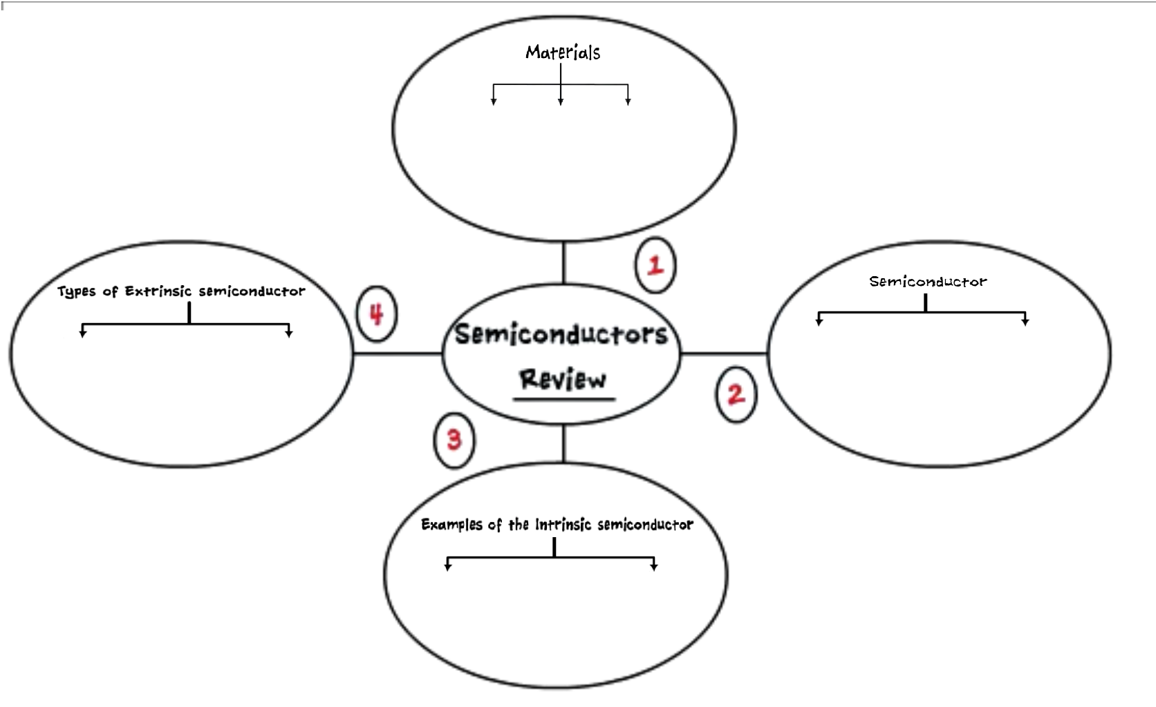

Complete the scheme with the necessary informations: